Support Manual Diehl Aerospace 8D Report with Office 2010

1. Precondition
To work with Diehl Aerospace Excel template the following set up adjustments in Excel has to be done:

- In register "Developer" select pushbutton Macro Security…

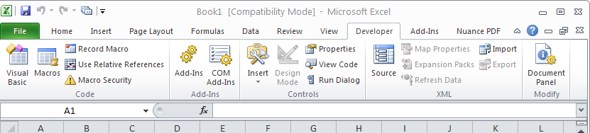

- Select "Enable all Macros…" and "Trust access to the VBA project object model" .

- Enter "OK" to close set up session

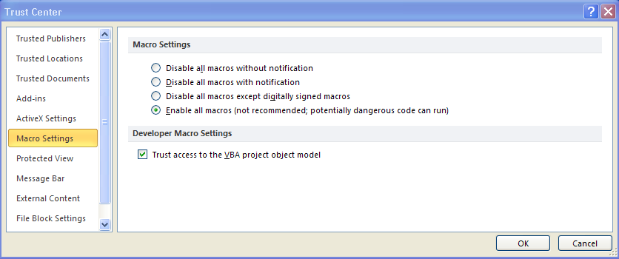

2. Template

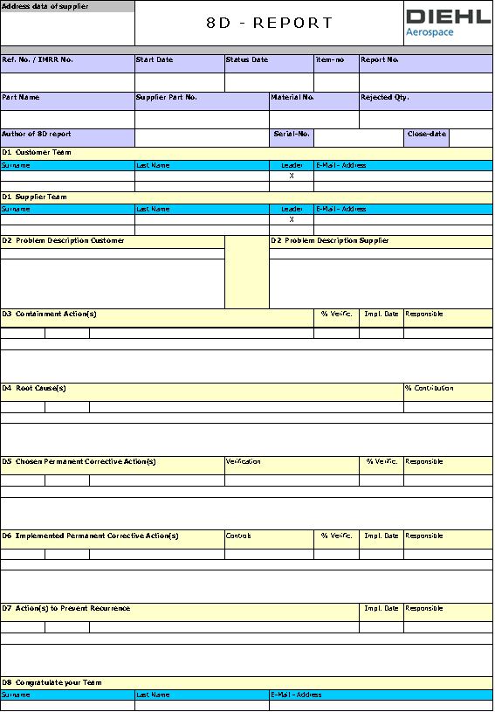

3. General Remarks

- All input cells, which are not in the scope of the supplier, are write protected. It is forbidden to unprotect them.
- Do not include/generate new cells (own fields (rows or columns) in Excel
- If additional input fields are necessary, these fields have to be generated by selecting in register „Add-Ins“ the related “Pushbuttons”.

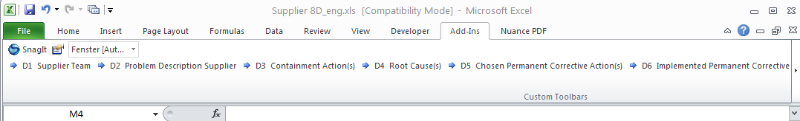

- Shaded/colored marked areas are only headlines.
- The header area will be filled by Diehl Aerospace.

- Header Area of the Template

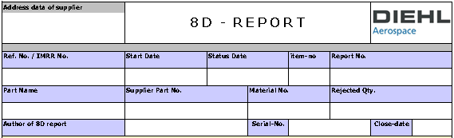

a.) Address data of the supplier
These boxes are filled out by Diehl Aerospace.
b.) Ref. No. /IMRR No.:
This cell has not to be filled out by the supplier.
c.) Start Date:
Describes the date of Diehl Aerospace complaint.
d.) Status Date:
Covers the date of the Diehl Aerospace 8D report request.
e.) Item-no.:
This is a reference to the position/item number of the Diehl Aerospace internal Quality Report, for which the 8D-Report is requested.
f.) Report-Nr.:
This field is a Diehl Aerospace internal reference number for this 8D report.
g.) Part Name:
This field covers the material description and is filled in by Diehl Aerospace.
h.) Supplier Part No.:
Covers the supplier reference number and is filled in by Diehl Aerospace.
i.) Material-Nr.:
Covers the Diehl Aerospace internal material reference number of the rejected material.
k.) Rejected Quantity:
Amount of rejected items.
l.) Author of 8D Report:
Covers the Diehl Aerospace responsible assistant, who has raised the query.
m.) Serial.-No.:
Cover the serial number of the rejected item, if applicable.
n.) Close Date:
This cell will be filled out by Diehl Aerospace after internal and external completion of the 8D root cause.
- D1 Customer Team:

These cells are filled by Diehl Aerospace and cover all involved Diehl Aerospace team members for the related rejection. The team leader will be marked via a "X" in the column "Leader". Each row covers only one team member.

- D1 Supplier Team
These cells have to be filled out by the supplier. In the first row the team leader has to be nominated. If more than 2 rows are needed, additional rows can be included by clicking the push button "D1 Supplier Team" within the register „Add-Ins”.

- D2 Problem Description Customer

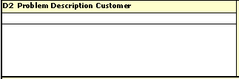
short text
long text

This field covers the Diehl Aerospace problem description of the rejected material. The first cell contains the short text (40 characters) whereas in the second field the long text of the problem description will be printed.

- D2 Problem Description Supplier

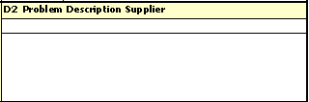
short text (max. 40 characters)

long text

These cells have to be filled out by the supplier. The first cell contains the short text (40 characters) whereas in the second field the long text of the problem description has to be entered. Clicking the push button "D2 Problem Description Supplier" in the register “Add-Ins” will bring the cursor to the related cell of the Excel sheet.

- D3 Containment Action(s)

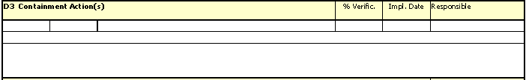

Within these cells the supplier has to define his immediate actions necessary to correct the rejection. These actions have to be filled in as short text in the small row and as long text in the expanded row. The cells having headlines have to be filled out for:
"%Verific." expected effectiveness,
"Impl. Date" date of introduction for immediate actions and in cell
"Responsible" the name of the responsible staff for the immediate action.

All other cells are protected against data entering.

If more than one immediate action has to be listed, additional rows can be generated by clicking the push button "D3 Containment Action(s)" in the register Add-Ins. Doing this, three new rows will be generated:
1. row "%Verific.", "Impl. Date", "Responsible",
2. row short text for immediate action declaration
3. row long text for immediate action declaration.

- D4 Root Cause(s)

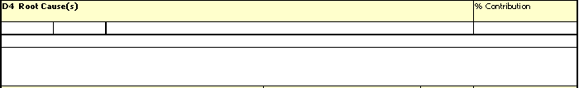

Within this area the supplier has to enter the root cause analysis results. These results have to be filled in as short text in the small row and as long text in the expanded row. In the cell with the headline
"%Contribution" the percentage involvement of the root cause for the rejection has to be entered..

All other cells are writing protected.

If more than one root cause was the reason for the rejection, additional fields can be generated by clicking the push button "D4 Root Cause(s)” in the register “Add-Ins”. Doing this, three new rows will be generated:
1. row "% Contribution",
2. row short text of the root cause
3. row long text of the root cause.

- D5 Chosen Permanent Corrective Action(s)

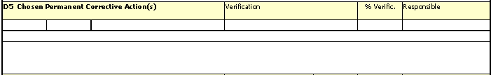

Within these cells the supplier has to enter the intended permanent corrective actions in order to correct the root cause for the rejection. These results have to be filled in as short text in the small row and as long text in the expanded row. In the cell with the headline

"Verification" the verification method for the effectiveness has to be entered.
"%Verific." the percentage involvement of the corrective action has to be entered
"Responsible" the name of the responsible staff for the related corrective actions.
All other cells are writing protected.

If more than one intended containment action is necessary, than additional fields can be generated by clicking the push button "D5 Chosen Permanent Corrective Action(s)" in the register “Add-Ins”. Doing this, three new rows will be generated:
1. row Verification, % Verific., Responsible,
2. row short text for related action
3. row longtext for related action.

- D6 Implemented Permanent Corrective Action(s)

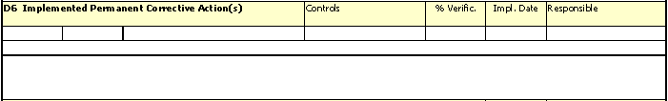

Within these cells the supplier has to enter the implemented permanent corrective actions necessary to prevent a new rejection with the same root cause. These results have to be filled in as short text in the small row and as long text in the expanded row. In the cells with the headline
"Controls" the verification document demonstrating the implementation of action has to be entered
"% Verific." the percentage involvement of the permanent corrective action has to be entered
"Impl. Date" date of implementation for the permanent corrective action
"Responsible" the name of the responsible staff for the related implemented actions.

All other cells are writing protected.

If more than one implemented permanent corrective action has to be listed, than additional fields can be generated by clicking the push button "D6 Implemented Permanent Corrective Action(s)" in the register “Add-Ins”. Doing this, three new rows will be generated:
1. row Controls, % Verific., Impl. Date, Responsible,
2. row short text for related action
3. row logn text for related action.

- D7 Action(s) to Prevent Recurrence

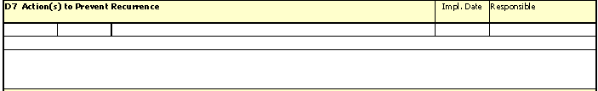

Within these cells the supplier has to enter preventing actions necessary to prevent the recurrence for a rejection with the same root cause for future deliveries. These information have to be filled in as short text in the small row and as long text in the expanded row. In the cell with the headline
"Impl. Date" date of implementation for preventing actions has to be entered.
"Responsible" name of responsible staff for implemented preventing actions.

All other cells are writing protected.

If more than one action has to be listed, than additional fields can be generated by clicking the push button "D7 Action(s) to Prevent Recurrence" in the register “Add-Ins”. Doing this, three new rows will be generated:
1. row Impl. Date, Responsible,
2. row short text for action
3. row long text for action.

- D8 Congratulate Your Team

These cells will be filled out by Diehl Aerospace personal. Clicking the related push button in register Add-Ins” will only move the cursor to the related cell.

